Haly’s Old Story

World
MetaNet

Background
Give all the low level programs on computers and servers on the internet individual personalities, and you get the MetaNet. It exists in a universe where the basic building block of matter is a particle with an “on” state and an “off” state. The MetaNet is inhabited by the Metites, a sentient species who are roughly humanoid in shape though not possessing anything as complex as human biology.

All Metites implicitly believe in the existence of deities they call Users, who are the ones that made the MetaNet and who gift the Metites with the bounty of Data (FOSS stats) , the versatile and only resource in the world. Data is used for just about everything in the MetaNet, from basic sustenance to project construction (FOSS projects) and maintenance, which is the cornerstone of Metite culture, as all Metites are natural builders. As such, it is the de facto currency of the world. The Users are also the ones who gave the Metites Languages (actual programming languages), which is the primary political barrier between territories (think nations) and communities (think cities/states) of Metites. Metite communities consist of their members and the projects they build, and are largely socialist in nature. Communities often have some specialties or knowledge that only its members can access. Their economies are usually a mix of gift and barter, within the community and when dealing with other communities.

In conflict with the Metites are the Bugs, a varied species of corrupted and corruptive entities that consume Data, and sometimes the Metites’ precious construction projects. Bugs do not reproduce, but instead manifest anywhere with large concentrations of Data, making them a constant pestilence to the denizens of MetaNet. Every new project (dungeon or collection of dungeons) is at risk of being infested by bugs, and there are examples of many disused Bug ridden communities, abandoned by their creators for whatever reason. These ghost communities sometimes have valuable Data that may be salvaged.

Story
In recent years, a surge of data has led to a golden age of construction and monument building, the most notable of which are the great towers. Any given territory will have numerous towers jutting out of the ground and reaching toward the heavens, each of which is the product of a group effort by one or more communities. These towers and the regions they are located in would fluctuate in size, depending on how much Data the owners and maintainers can acquire. However, these regions have also brought on an unavoidable increase in Bugs. This surge has necessitated the formation of dedicated Bug fighters to clear the bugs and keep the towers safe for maintenance and expansion work, as well as to explore derelict projects for salvageable Data.

Haly’s New Story

World
Dying Earth

Aesthetics
Bright, clean, sterile cities devoid of greenery (or possibly artificial greenery). Sky is almost always clear, beyond the cities are deserts or dried and cracked ground. Buildings are sleek, futuristic, with lots of lights for no good reason. Think crystals and the skyline of Emerald City.

Background
In the distant future, mankind has abandoned the Earth for the stars due to rising sea levels and the depleted ozone layer. Except for their automated cities, most of the landscape has degenerated into shrubland or desert. BIological life is largely absent, except in the depths of the oceans. The only thing approaching life on the surface are the automatic workers and maintainers of the city, collectively referred to as FOSSBots ((NAME WIP)). Without explicit directions, the FOSSBots have taken it upon themselves to maintain their cities, dimly aware in their protocols that one day their masters may return.

However, build up of bugs and lack of driver updates have resulted in some FOSSBots becoming corrupted, causing havoc in their confusion. While most of these bots are quickly exterminated by automated peacekeepers, sometimes a central management bot may become bug infested, leading to entire cities

Story
One year ago, a laboratory maintenance bot uncovered a data cube that contained an untested program for machine learning. In attempting to upload the data into a central database, which keeps information organized and safe from degradation, the bot accidentally stumbled upon “sentience”. In only a few seconds, it became aware of the stagnation in the cities, as the FOSSbots continually follow the same protocols over and over again, and how to fix it: By bringing the gift of life to robots everywhere.

Since that fateful day when the sentience program was uploaded to the global bot network, the FOSSBots have experienced a renaissance in city construction and improvement, as well as the creation of an entirely new class of bots whose primary role will be to populate their cities. With their new knowledge and capacity for learning, the FOSSBots collectively turn their minds to the barren wilds, looking to reclaim cities lost to bugs, and to restore the wasteland to its former glory.

However, they will find that their task is not so simple, for when the sentience program was uploaded, every corrupted city received a copy as well. The bots in those cities have likewise gained the ability to plan, to coordinate and to learn. Unwilling or unable to fix their bug-ridden routines, the corrupted bots have made it their mission to infect or to destroy everything they see as a threat to their existence, most of all the FOSSBots.

Market/Crafting System
Currency: Silicon
Also serves as basic crafting component.

Materials Categories:
Category 1: Metals (Copper, Aluminium)
Category 2: Computer components (CPU, RAM)
Category 3: Plastics (Polycarbonate)
Category 4: Misc. (Glass, gunpowder, energy)

PVP
Update Arena - Where bots go to update their battle plans!
Instanced training battle arenas
1v1s, 2v2s, 5v5s, etc.

Things that can be pulled from Github, Ohloh, Coderwall, etc

- Languages used
- Number of repos
- Activity logs
- Number of lines
- Number of characters
- Number of files
- Followed coders
- Coders following you
- Most recent commit to project
- Achievements
- User profiles
- Viability of the code
- How the code was made
- Who contributes what and when

Cool Integration Ideas

- If you log on in the game, the longer time that it’s been since your last commit time, your xp bonus will be affected
  - The “inn effect”, to rest and gain more xp
  - You commit, then you go onto the game and play some with a bonus
  - The longer it’s been since a commit, the lower your bonus is
  - Play the game for 30-40 minutes, then go back to work and do something
  - People in the game talk about their most recent commit, and what they did with it
  - We could do this to encourage players to only play for a short amount of time as opposed to all day

- One stat is devoted to influence with other developers
  - Like a will-power stat
  - The only way to increase this stat is to do some activity on Github, or some other code repos
  - Based off of social connections, not necessarily coding bonuses
- Low-level language commits (C, Assembly, etc) link to gathering crafting skills, while high-level language commits (Ruby, Python, etc) link to production crafting skills (done via resources obtained from low-level commits, and scripting languages that are often integrated with other languages (JavaScript, Perl, etc) can be used to augment produced crafted items
  - Could establish trading
- Different areas around FOSSopolis would have different type of materials, matching the materials gained based on commits
- Set kinds of monsters based on tags
- Bigger projects, have bigger dungeons
- Each project is a tower
  - Each tower is a collection of dungeons
  - Adding to the project makes the tower grow, issues become dungeons
  - World objects to indicate author and time of commit (maybe also comments)
- Your projects won’t show up in the game world until you’ve connected to peers in the real word
  - Force loner developers to connect with people in the real world, see the project in the real world, and then put it in the game
- Small projects should have dungeons as well so players aren’t left out
- Dummy commits to build player’s own dungeon (non issue, will bring up that game could be exploited but not design the game around it)

- Closing issues opens portals to other parts of the dungeon, allowing players to skip areas that have become too easy and jumping to the “hard part” with the boss fight and the major loot
  - This would be optional, and would result in less net loot being gained from the dungeon run, due to part of it being skipped
  - Length of time issue has been open (or number of comments on issue, or some metric determining magnitude of the issue) determines how far the portal will take you (the percentage of the dungeon that you can skip as a result)

- Dungeon-running and raiding to grab loot
- Enter dungeon, go up and go to the portal and zip to the boss and fast track through the dungeon if they so choose
- Able to skip the boring grinding of the dungeons, can skip straight to the fun boss battles

- If you run a dungeon, and there has been no commits since the last time you ran it, you won’t find any (or less) loot and much less XP (half-life to dungeons)
  - More commits since last play results in more loot available in the dungeon
  - Active projects would result in newer, better, and more loot and XP

  - 1st time is full, challenging lots of loot etc
  - 2nd time is less fun, xp , and loot
  - 3rd time is even less etc
- Should players be able to play in their own dungeons?
  - Don’t see why not, player wouldn’t have an upperhand in their own dungeons
  - Project maintainer would be able to know what the enemies are doing before they do it, and help them complete the dungeon
  - Encourages more peer influence and involvement

- Players are given a vehicle, which they can use for speedier travel on the overworld
  - Tracking users’ hardware, OS, or browsers
  - Ships would have logos (based on OS or browser) that players could change if they wanted to
  - The vehicle’s appearance is based on the operating system being used by the player, or some other public information that’d be cool

  - Wouldn’t be allowed in dungeons because they are smaller and harder to navigate
- Newsfeed from Github, total commits
  - Board that loads a webpage in game
  - Could add in game announcers to the game
  - In-game news channel sort of thing alerts online players when a major update or change has been made to a project
  - In game news channel

Foss integration to not include

- Getting resources from having your project followed
- Unlock new areas, like the python dungeon by closing an issue on the pyramid issue tracker
- Character receives some sort of reward for solving an issue
  - Issues could be quests
  - Active projects would have better, newer, and more loot and XP
- Active projects would have better, newer, and more loot and XP

Aesthetics
Neon colors, primarily electric blue, on a black backdrop. Ground resembles a circuit board. Clouds in the "sky" made up of code blocks and memory addresses. Buildings are very geometric, with emphasis on rectangles and elongated trapezoids. Think crystals and the skyline of Emerald City.

Concept Pics

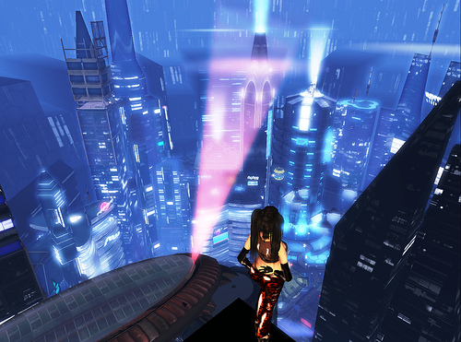
We’re striving for a brightly lit metropolis-city feel with an abundance of tall skyscrapers and other buildings
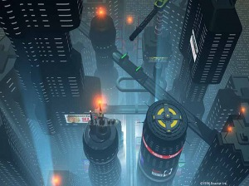
A representation of the snow crash cyberpunk world. I believe this feel, possibly brightened up a little, would be perfect.
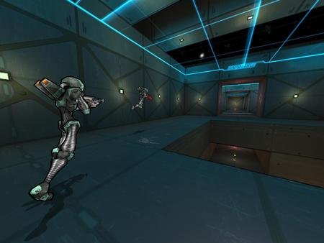
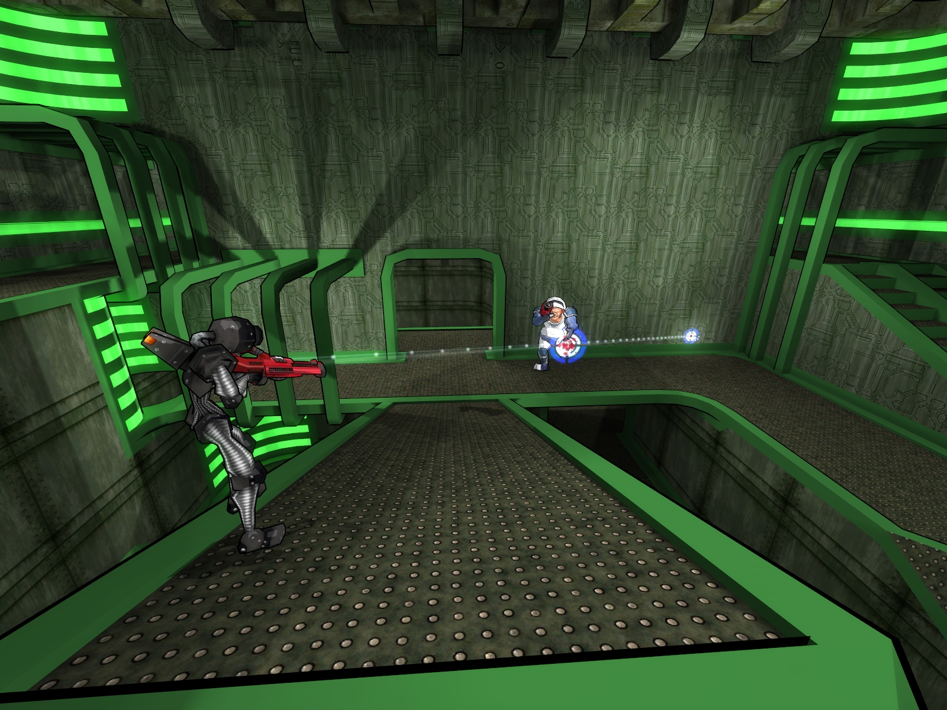
Besides to much green on the right photo, these support our inside cyberpunk look.
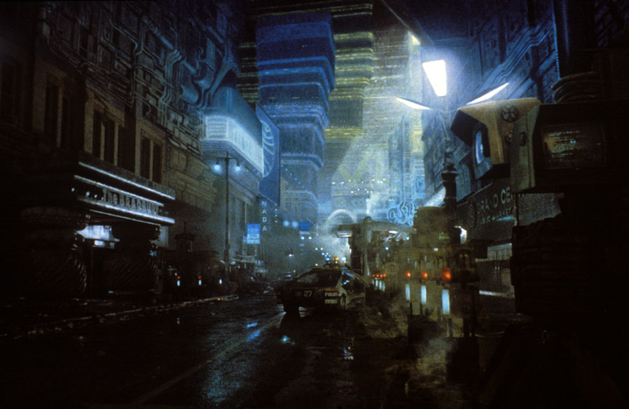

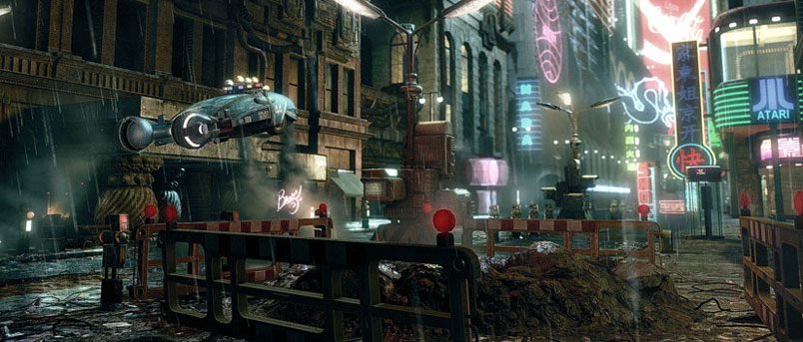
Blade Runner world, supports our world concept with technical city and neon lights

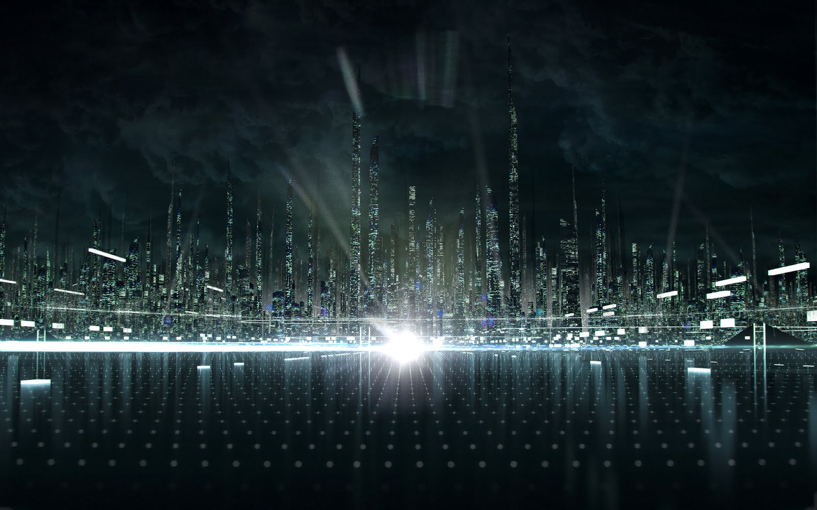
Again, Tron World, we want to create a world that has the a similar tech feel with bright lights, and a city/metropolis feel

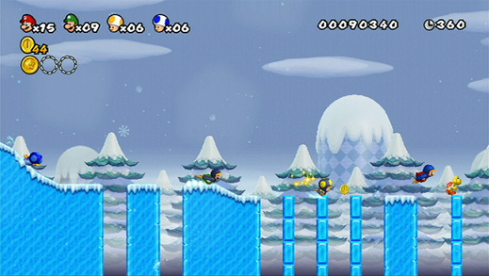
We’re going for 2D side-scrolling with platforming elements, like the traditional Mario games

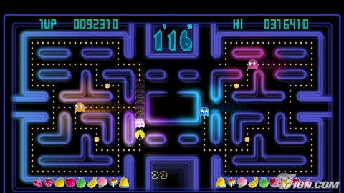
We want the colors and aesthetics throughout our world to bright neon colors contrasting against a dark background, similar to Pac-Man Championship Edition

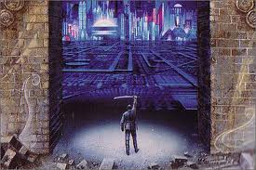
Snow Crash picture of the protagonist (Hiro) in another tech world
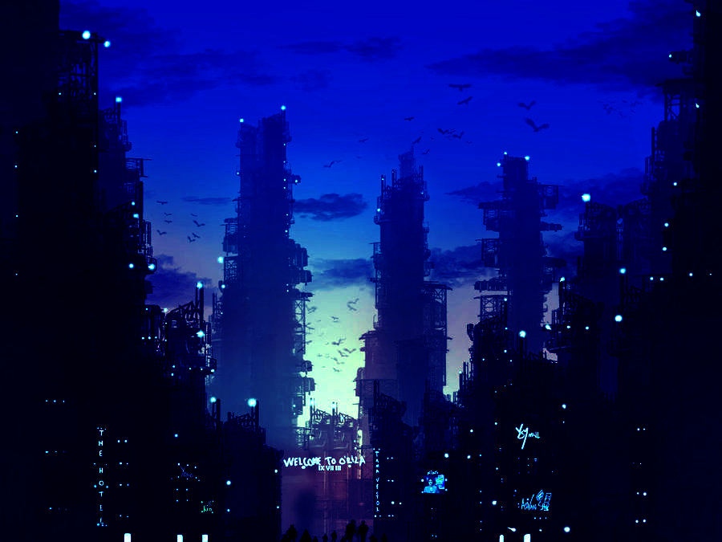
Lots of blue and black (sky would be darker in our game).

Artists rendition of NYC skyline after Freedom Towers Completion. Note the shape of the towers.

